**Report generator**

This document contains the Report generation queries and the screenshots of the specified reports.

1. **Top 10 under-utilised Ad campaigns**

*select*

*tab3.campaignID as campaignID,*

*tab3.category as category,*

*tab3.click as click,*

*tab3.acquisition as acquisition,*

*tab3.view as view,*

*round(tab3.expenditure / tab3.totalbudget * 100,5) as budgetUtilization*

*from*

*(*

*select*

*tab1.campaign_id as campaignID,*

*tab2.category as category,*

*tab1.click as click,*

*tab1.acquisition as acquisition,*

*tab1.view as view,*

*tab1.expenditure as expenditure,*

*tab2.budget as remainingBudget,*

*tab1.expenditure + tab2.budget as totalBudget*

*from*

*(*

*select*

*feedback.campaign_id as campaign_id,*

*sum(feedback.view) as view,*

*sum(feedback.click) as click,*

*sum(feedback.acquisition) as acquisition,*

*sum(feedback.expenditure) as expenditure*

*from ad_platform.adsfeedback as feedback*

*group by feedback.campaign_id*

*) as tab1*

*inner join ad_platform.ads as tab2*

*on tab1.campaign_id = tab2.campaignid*

*) as tab3*

*order by budgetUtilization*

*limit 10;*

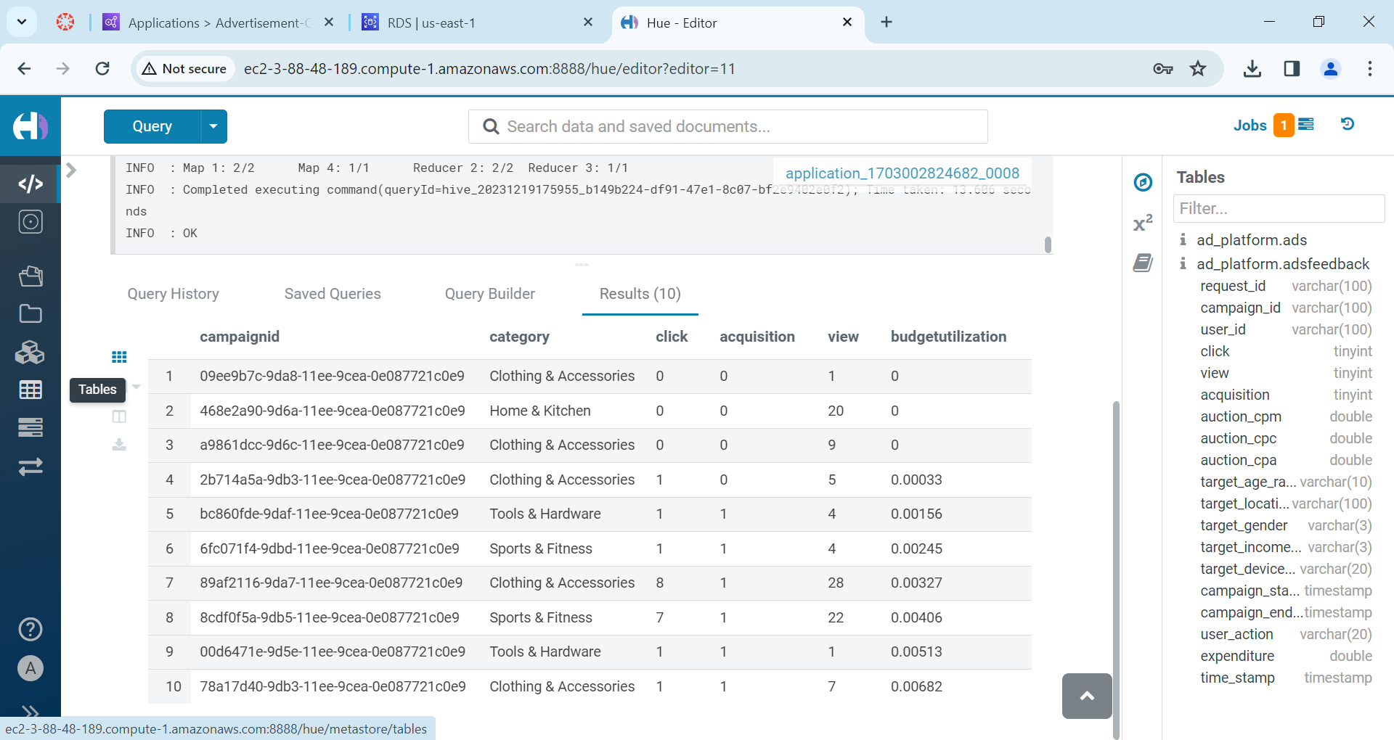

1. **Top 10 spending Ad campaigns**

*select*

*tab3.campaignID as campaignID,*

*tab3.category as category,*

*tab3.click as click,*

*tab3.acquisition as acquisition,*

*tab3.view as view,*

*round(tab3.expenditure / tab3.totalbudget * 100,5) as budgetUtilization*

*from*

*(*

*select*

*tab1.campaign_id as campaignID,*

*tab2.category as category,*

*tab1.click as click,*

*tab1.acquisition as acquisition,*

*tab1.view as view,*

*tab1.expenditure as expenditure,*

*tab2.budget as remainingBudget,*

*tab1.expenditure + tab2.budget as totalBudget*

*from*

*(*

*select*

*feedback.campaign_id as campaign_id,*

*sum(feedback.view) as view,*

*sum(feedback.click) as click,*

*sum(feedback.acquisition) as acquisition,*

*sum(feedback.expenditure) as expenditure*

*from ad_platform.adsfeedback as feedback*

*group by feedback.campaign_id*

*) as tab1*

*inner join ad_platform.ads as tab2*

*on tab1.campaign_id = tab2.campaignid*

*) as tab3*

*order by budgetUtilization desc*

*limit 10;*

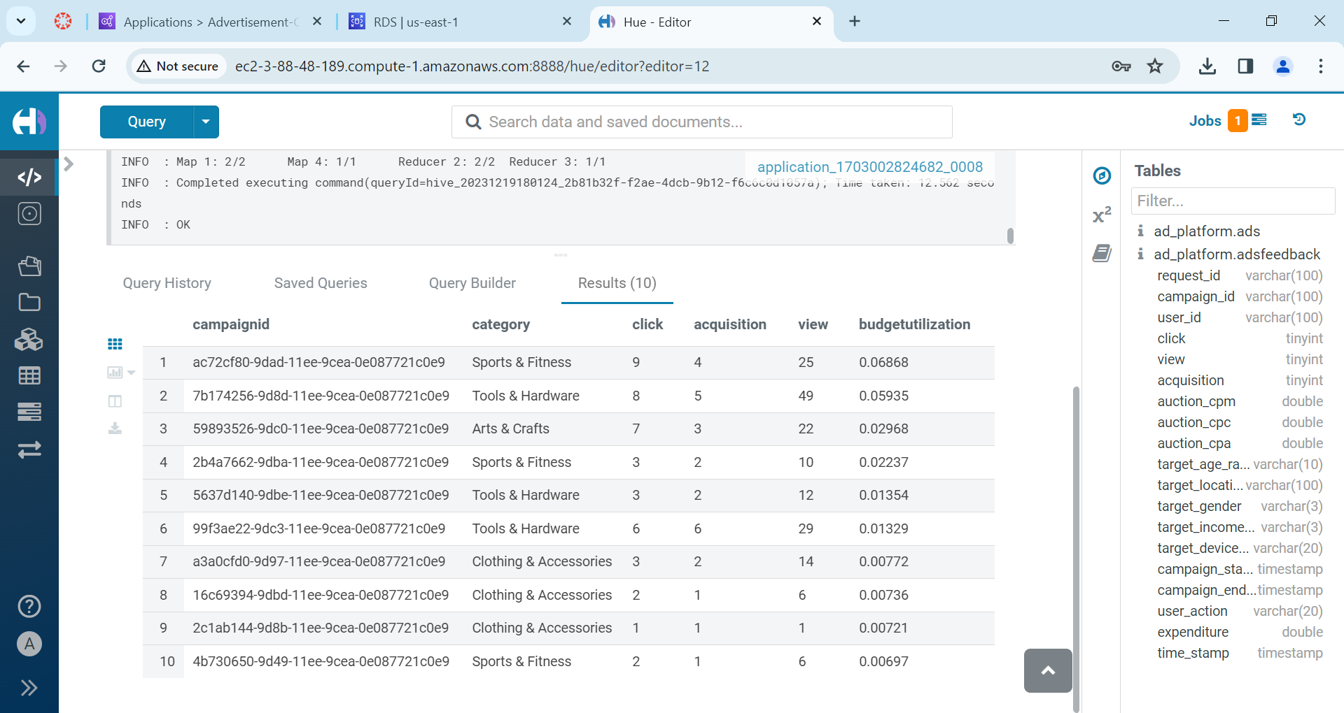

1. **Total expenditure and click-through rates (CTR) of Ad campaigns**

*select*

*feedback.campaign_id as campaign_id,*

*round(sum(feedback.click) / sum(feedback.view),6) as CTR,*

*round(sum(feedback.expenditure),6) as expenditure*

*from ad_platform.adsfeedback as feedback*

*group by feedback.campaign_id;*

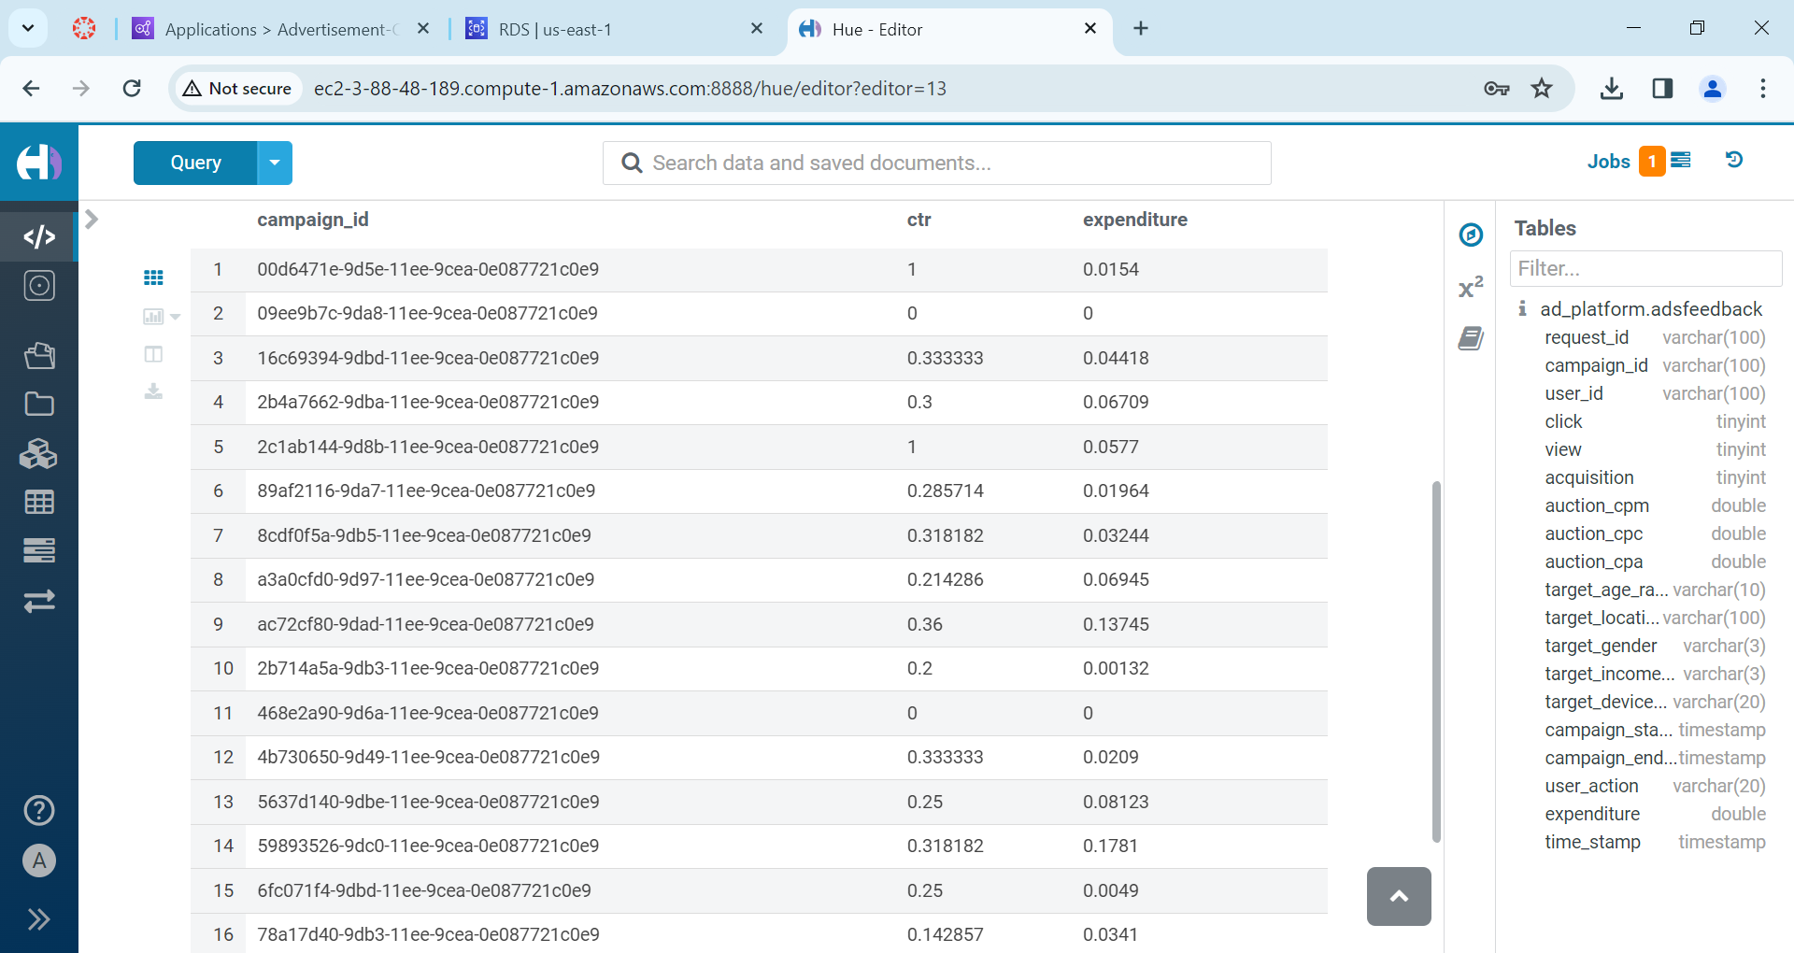

1. **Top five interactive (highest CTRs) age groups**

*select*

*tab1.ageRange as age_group,*

*sum(tab1.CTR) as CTR*

*from*

*(*

*select*

*feedback.campaign_id as campaignID,*

*feedback.target_age_range as ageRange,*

*feedback.click / feedback.view as CTR*

*from ad_platform.adsfeedback as feedback*

*) as tab1*

*group by tab1.ageRange*

*order by CTR desc*

*limit 5;*

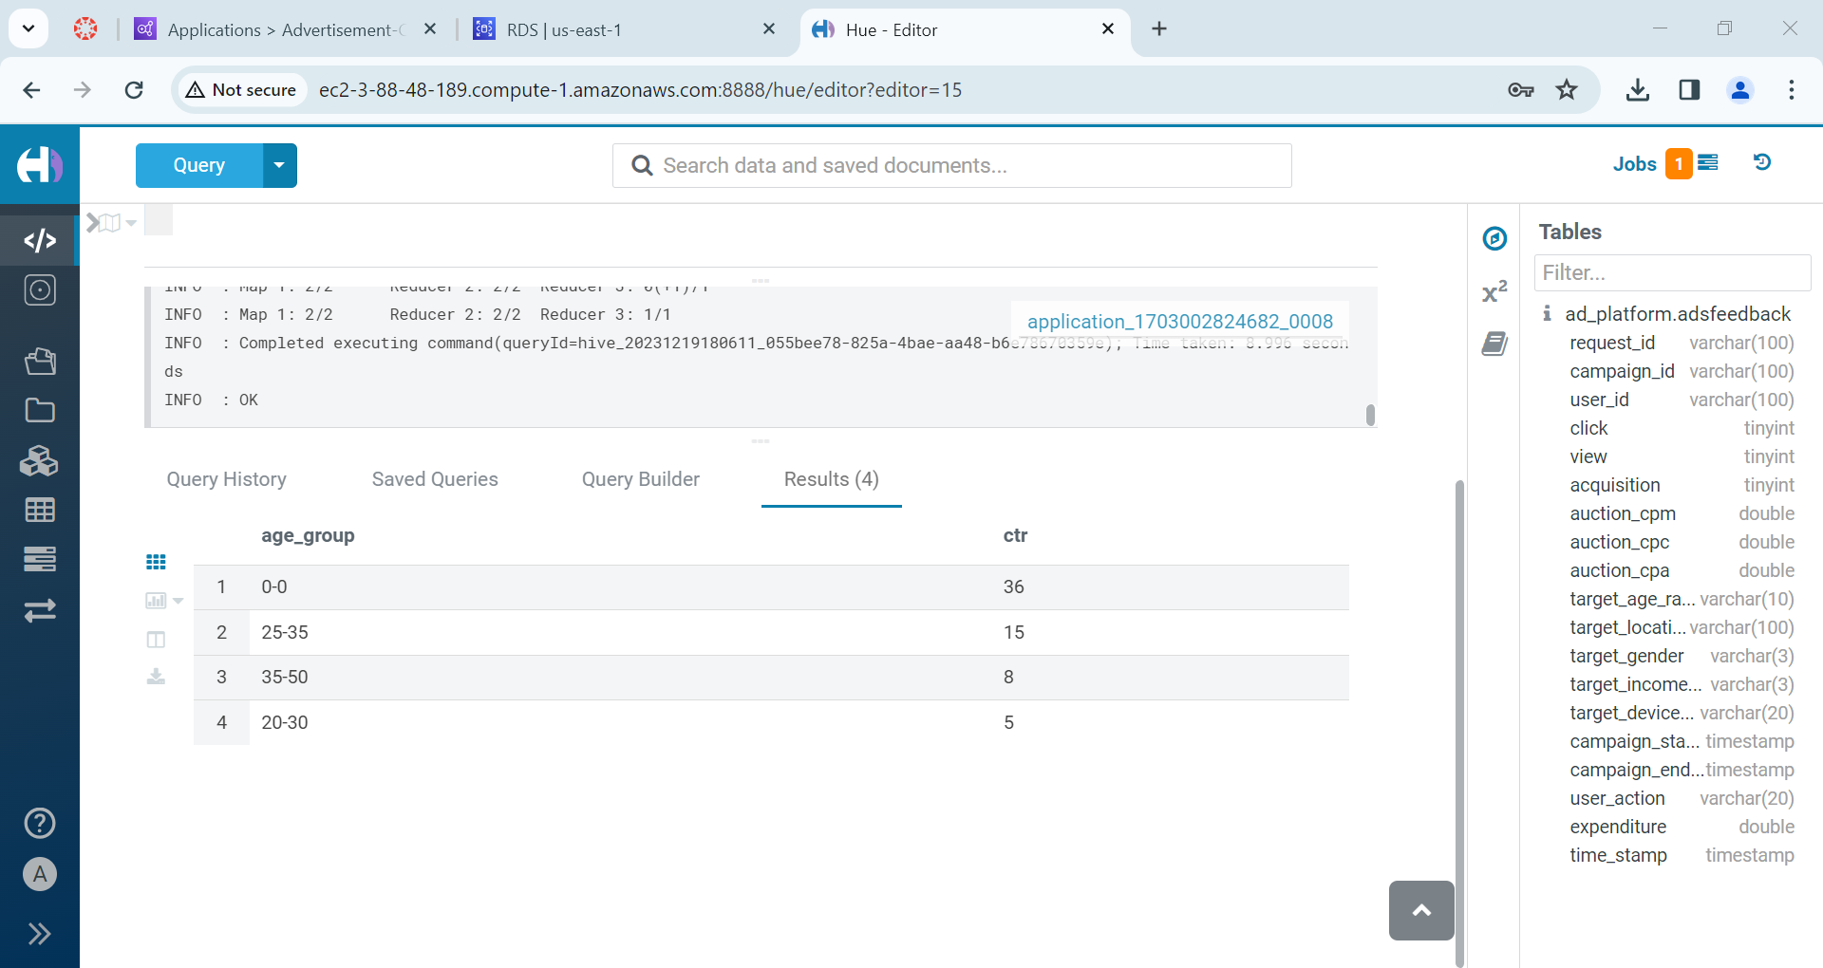

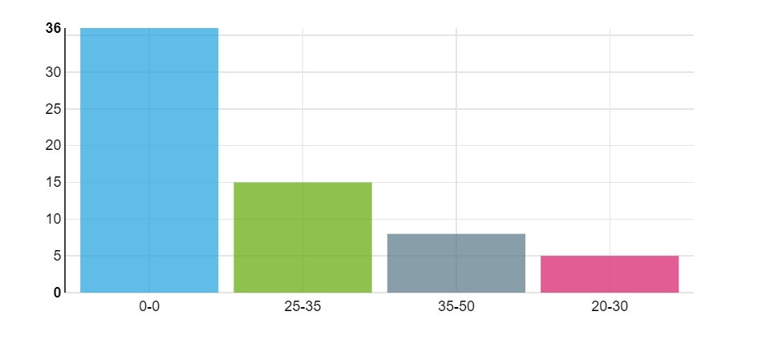

1. **Top five interactive locations**

*select*

*tab1.location as location,*

*sum(tab1.CTR) as CTR*

*from*

*(*

*select*

*feedback.campaign_id as campaignID,*

*feedback.target_location as location,*

*feedback.click / feedback.view as CTR*

*from ad_platform.adsfeedback as feedback*

*) as tab1*

*group by tab1.location*

*order by CTR desc*

*limit 5;*

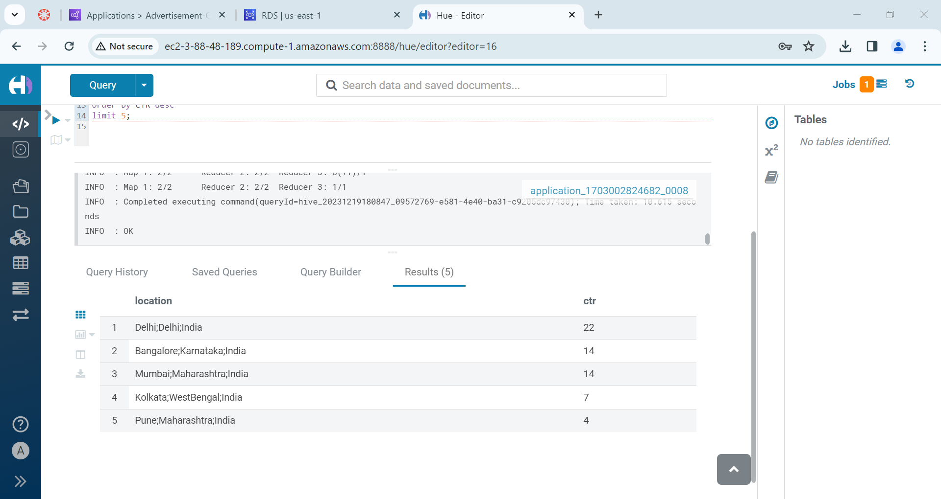

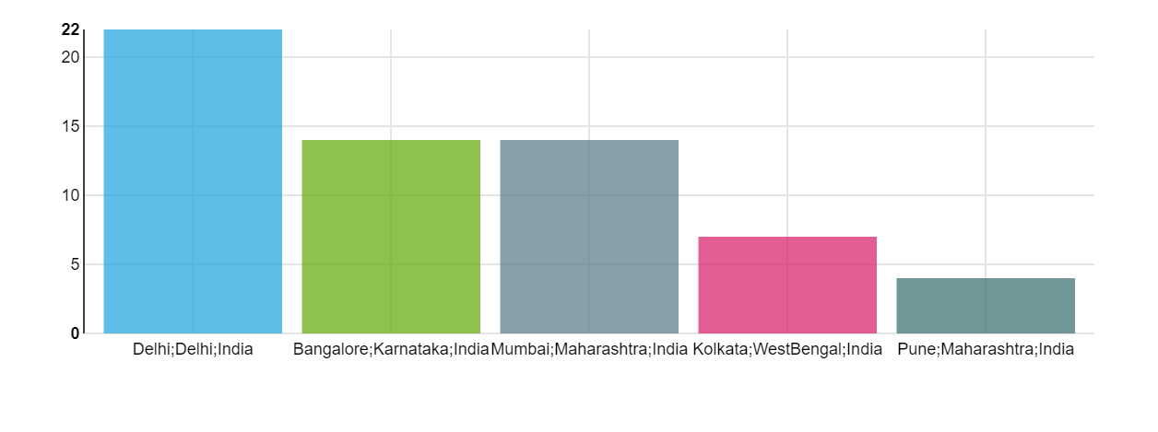

1. **Top interactive gender**

*select*

*tab1.gender as gender,*

*sum(tab1.CTR) as CTR*

*from*

*(*

*select*

*feedback.campaign_id as campaignID,*

*feedback.target_gender as gender,*

*feedback.click / feedback.view as CTR*

*from ad_platform.adsfeedback as feedback*

*) as tab1*

*group by tab1.gender*

*order by CTR desc;*

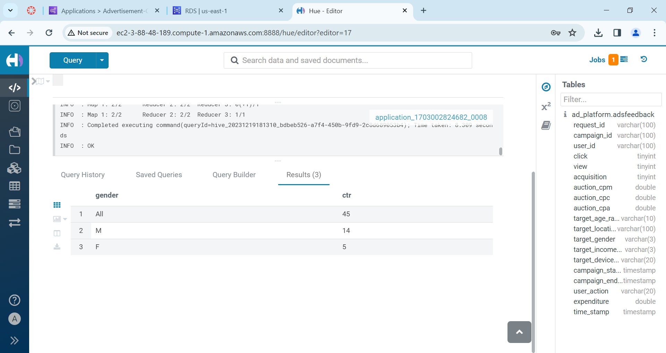

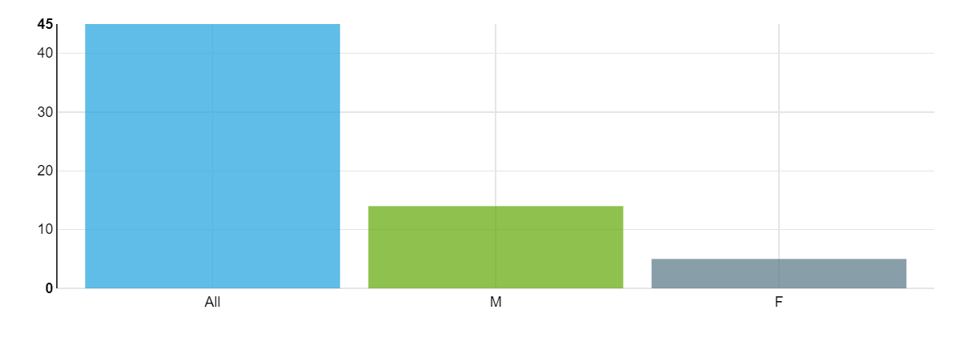

1. **Top interactive income buckets**

*select*

*tab1.income_bucket as income_bucket,*

*sum(tab1.CTR) as CTR*

*from*

*(*

*select*

*feedback.campaign_id as campaignID,*

*feedback.target_income_bucket as income_bucket,*

*feedback.click / feedback.view as CTR*

*from ad_platform.adsfeedback as feedback*

*) as tab1*

*group by tab1.income_bucket*

*order by CTR desc;*

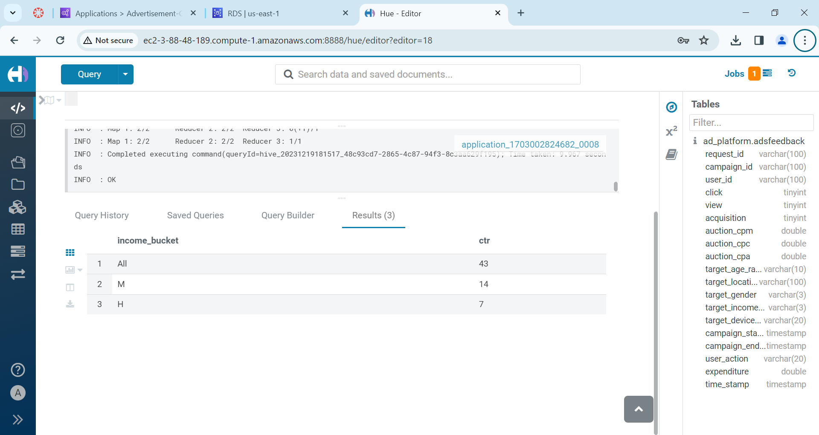

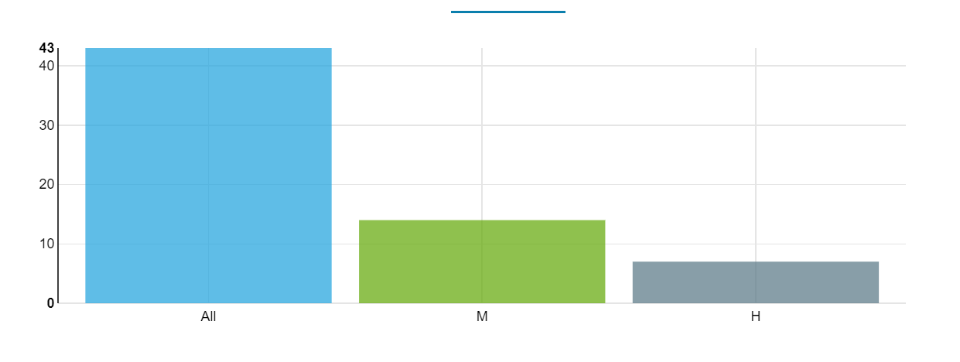

1. **Top five interactive device types**

*select*

*tab1.device_type as device_type,*

*sum(tab1.CTR) as CTR*

*from*

*(*

*select*

*feedback.campaign_id as campaignID,*

*feedback.target_device_type as device_type,*

*feedback.click / feedback.view as CTR*

*from ad_platform.adsfeedback as feedback*

*) as tab1*

*group by tab1.device_type*

*order by CTR desc*

*limit 5;*

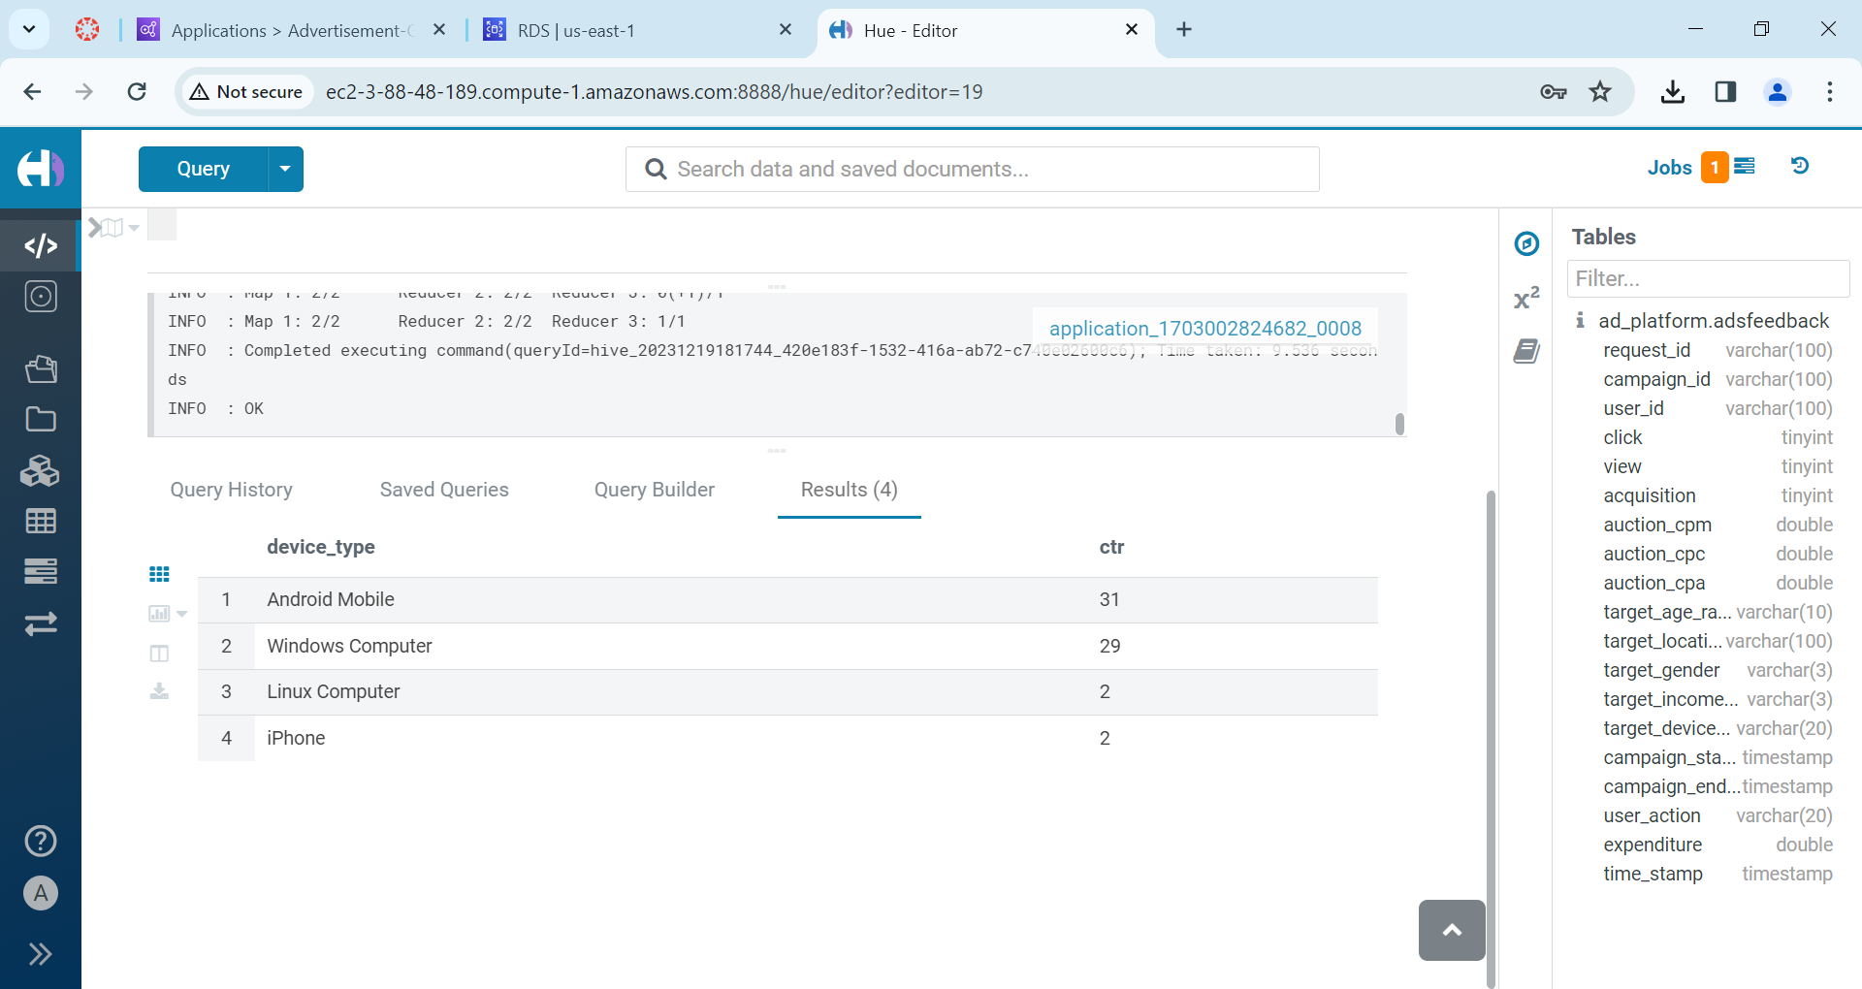

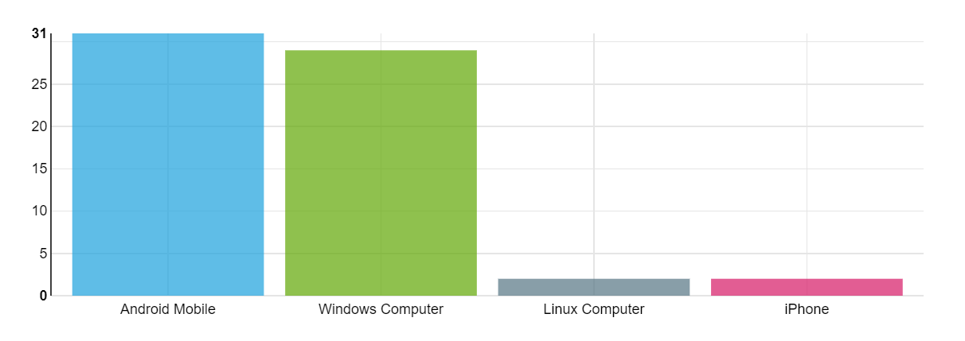

1. **Top 10 spending Ad categories**

*select*

*tab2.category as category,*

*round(sum(tab1.expenditure),6) as expenditure*

*from ad_platform.adsfeedback as tab1*

*inner join ad_platform.ads as tab2*

*on tab1.campaign_id = tab2.campaignid*

*group by category*

*order by expenditure desc*

*limit 10;*

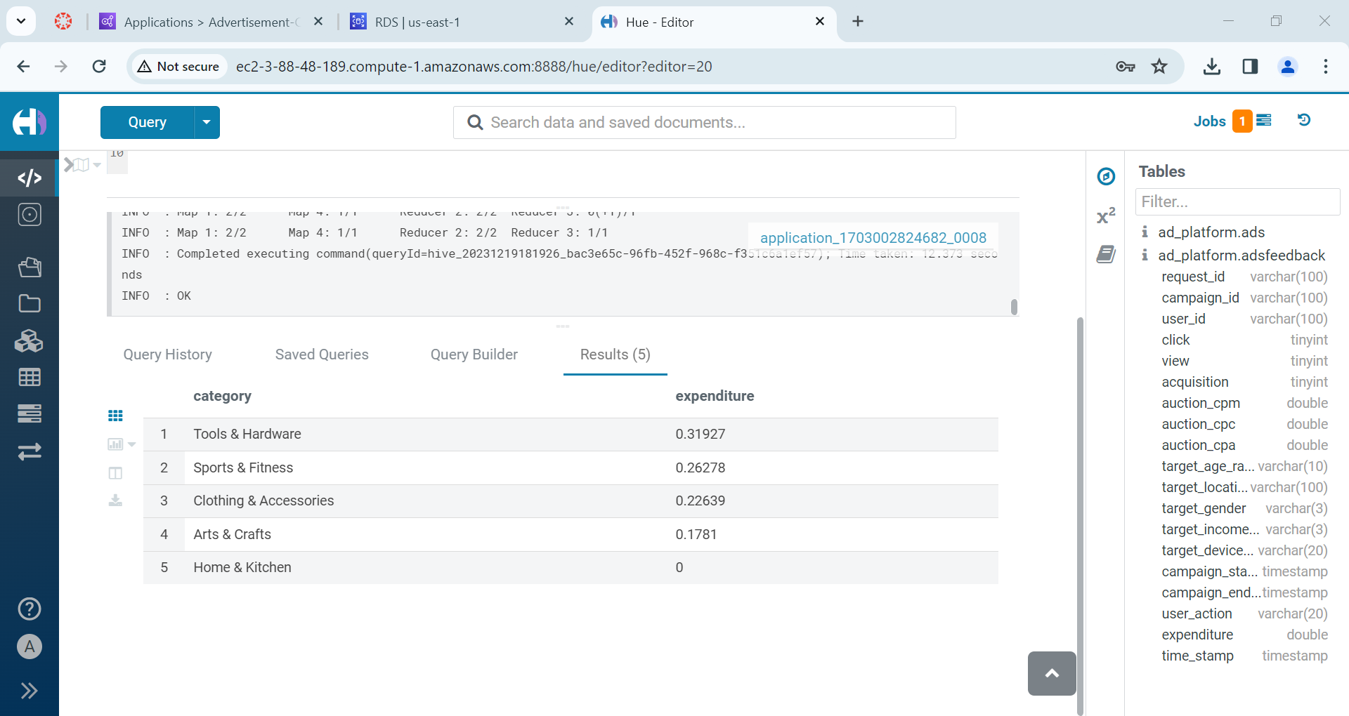

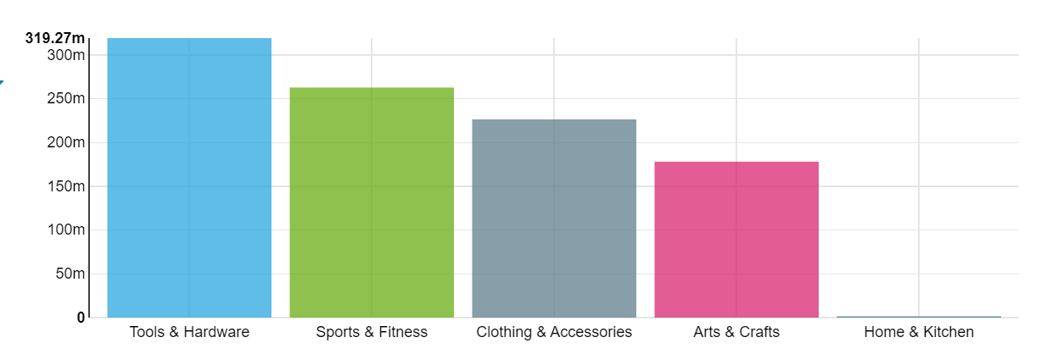

1. **Highest price differences in CPM during auctions**

*select*

*tab1.request_id as request_id,*

*tab2.cpm -tab1.auction_cpm as difference*

*from ad_platform.adsfeedback as tab1*

*inner join ad_platform.ads as tab2*

*on tab1.campaign_id = tab2.campaignid*

*order by difference desc;*

